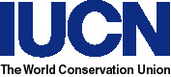 | 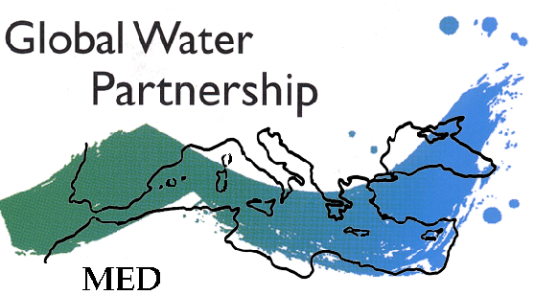
IUCN Centre for Mediterranean Cooperation | Global Water Partnership – Mediterranean

Roundtable on Water, Wetlands and Climate Change
in the Mediterranean

10-11 December 2002

Divani Caravel Hotel, Athens, Greece

Organized by IUCN and GWP-Med

Registration Form

Name: (Mr. / Ms.) …………………………………………………………………………….
Title: ………...………………………………………………………………………………….
Organization: ………………………………………………………………………………….
Address: ………………………………………………………………………………….
………………………………………………………………………………….
Country: ……………………………………………….
Tel: ………………………………………………………………………………….
Fax: ………………………………………………………………………………….
E-mail: ………………………………………………………………………………….
Web site: ………………………………………………………………………………….

I would like to participate in the Conference: YES NO

Date of Arrival: ………………………………………………………………………….
Date of Departure: …………………………………………………………………….

There are no registration fees. Date: ………………….

PLEASE RETURN THIS FORM BY 30 October 2002 to:

GWP-Med Secretariat
c/o MIO-ECSDE
28, Tripodon str, 10558 Athens,
Tel: +3010-3247490; Fax: +3010-3225240
E-mail: secretariat@gwpmed.org
Web site: www.gwpmed.org
N.B. On Nov. 3rd, the telephone area code prefix for Athens will change from +3010 to +30210

